Press release

Kasteel Wijlre presents solo exhibition of Oscar Lourens in 2021

From 10 March 2021 onwards, Kasteel Wijlre estate presents a solo exhibition of Oscar Lourens (1973). ‘GREY MATTERS’ shows Lourens’s fascination for collections which focus on scale, form, color, and space.

Floor plans, cross-sections, models and data comprise an exhaustive archive arranged into folders, binders, card trays, display cases and filing cabinets. Like a true collector, Lourens conserves various measuring instruments, such as measuring cups that are all unique and made of different materials such as glass and plastic. He has also collected an extensive collection of rulers and set squares. By painting the objects with grey primer, he strips the rulers and measuring cups of their gauging function. The paint, however, makes details such as measurement indications and typography more visible; the rulers and beakers now only refer to measuring.

In his pursuit of intriguing forms, Lourens has also amassed an impressive collection of globes. As well as their shape, he is intrigued by the reflections of glass globes. The presentation’s economy of means derives from stripping the items of their function to become pure object. This work, which is shown here for the first time, also maintains an apparent reference to the display of natural history collections. This reference is present in other works in this exhibition as well.

Lourens previously developed a route through the Kasteel Wijlre estate’s garden. Based on the idea of the Cyanometer – an eighteenth-century invention that measures the different blues of the sky according to 53 tones – the Greyometer was developed to measure the grey intensity of various objects. Lourens thus connects his interest in ordering and controlling reality and the critique of the feasibility of such actions. In the exhibition at the Coach House, Lourens interrogates the contrast between sustainability and ephemerality. In his rigorous world of dimensions, scale models, metres and cubic centimetres, Lourens’ works encourage reflection and wonder.

About Kasteel Wijlre estate
Kasteel Wijlre is an estate for art, nature, architecture and heritage. The estate presents exhibitions, projects, events, walking routes and educational activities in the Hedge House contemporary art pavilion, the historic Coach House and the garden.

www.kasteelwijlre.nl

Open to the public from 10 March to 7 November 2021, from Wednesday to Sunday, 11.00–17.00
Entrance: Kerkpad 1, Wijlre

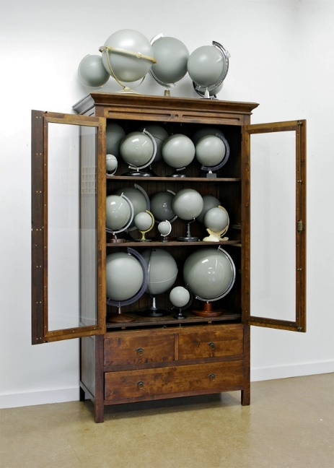

Untitled (2015-16). Collection Museum Voorlinden, Wassenaar

Not for publication

For more information and images, please contact
Manon Berns via m.berns@kasteelwijlre.nl

