Press release

Kasteel Wijlre presents international group exhibition ‘Spirit of Kindergarten’ in 2021

In 2021, Kasteel Wijlre estate will organise the international group exhibition Spirit of Kindergarten about the relationship between the ideas of the German educationalist Friedrich Fröbel (1782–1852) and modern and contemporary art and architecture. The exhibition shows work by eight artists intertwined with loans from the collections of art collectors and founders of Kasteel Wijlre estate, Jo and Marlies Eyck, Bonnefanten, Museum Insel Hombroich, Het Nieuwe Instituut and the National Education Museum.

Kindergarten is an avant-garde teaching method developed by the German educator Friedrich Wilhelm Fröbel (1782-1852). He founded a Kindergarten around 1840; a garden that was the ideal environment for children’s play. Fröbel’s teaching materials, some of which are included as a starting point to this exhibition, used the shapes and colours from which nature is built. Fröbel’s ideas, visual language and formal language have since had a significant influence on artists, designers and architects. Architect Frank Lloyd Wright referred directly to Fröbel’s materials when he said, ‘the maple wood blocks ... are still in my fingers to this day.’ Play objects, such as blocks, sewing cards and mosaic tiles, can be found in art-historical movements such as Futurism, Bauhaus and Minimalism.

Spirit of Kindergarten
The exhibition Spirit of Kindergarten shows the work of contemporary artists Otto Berchem, Francis Alÿs, Belen Uriel, Michel François, Eva Rothschild, David Renggli, Irma Cohen and Erwin Wurm, in whose work form, colour, material or the element of play is related to the concept of Kindergarten. These works of art are interwoven with the work of prominent representatives of Minimalism such as Ad Dekkers, Bob Bonies and Donald Judd, whose art pays the same attention to geometric abstraction.

In collaboration with the National Education Museum, Nivoz Foundation, The Froebel Trust (UK), Wellcome Trust (UK), the estate also presents a programme of lectures, films and educational labs.

Erich Weiss curates the exhibition at the Hedge House, which brings together works from various international collectors and collections.

About Kasteel Wijlre estate
Kasteel Wijlre is an estate for art, nature, architecture and heritage. The estate presents exhibitions, projects, events, walking routes and educational activities in the Hedge House contemporary art pavilion, the historic Coach House and the garden.

www.kasteelwijlre.nl

Open to the public from 10 March to 7 November 2021, from Wednesday to Sunday, 11.00–17.00
Entrance: Kerkpad 1, Wijlre

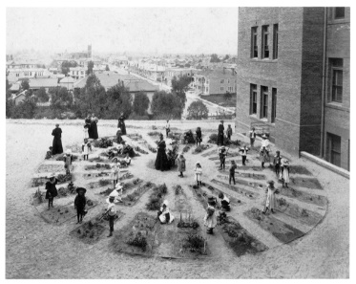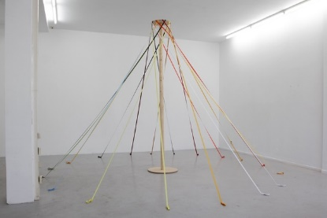
- Children’s garden, unidentified kindergarten, Los Angeles, c. 1900, source: Inventing Kindergarten, Norman Brosterman
- Otto Berchem, We Are The Revolution (Maypole), 2013, Wood with 18 ribbons, 3 x 4.5 m

Not for publication

For more information and images, please contact
Manon Berns via m.berns@kasteelwijlre.nl

